CONTRA-TIEMPO Futuro Summer Dance Intensive 2019 Application
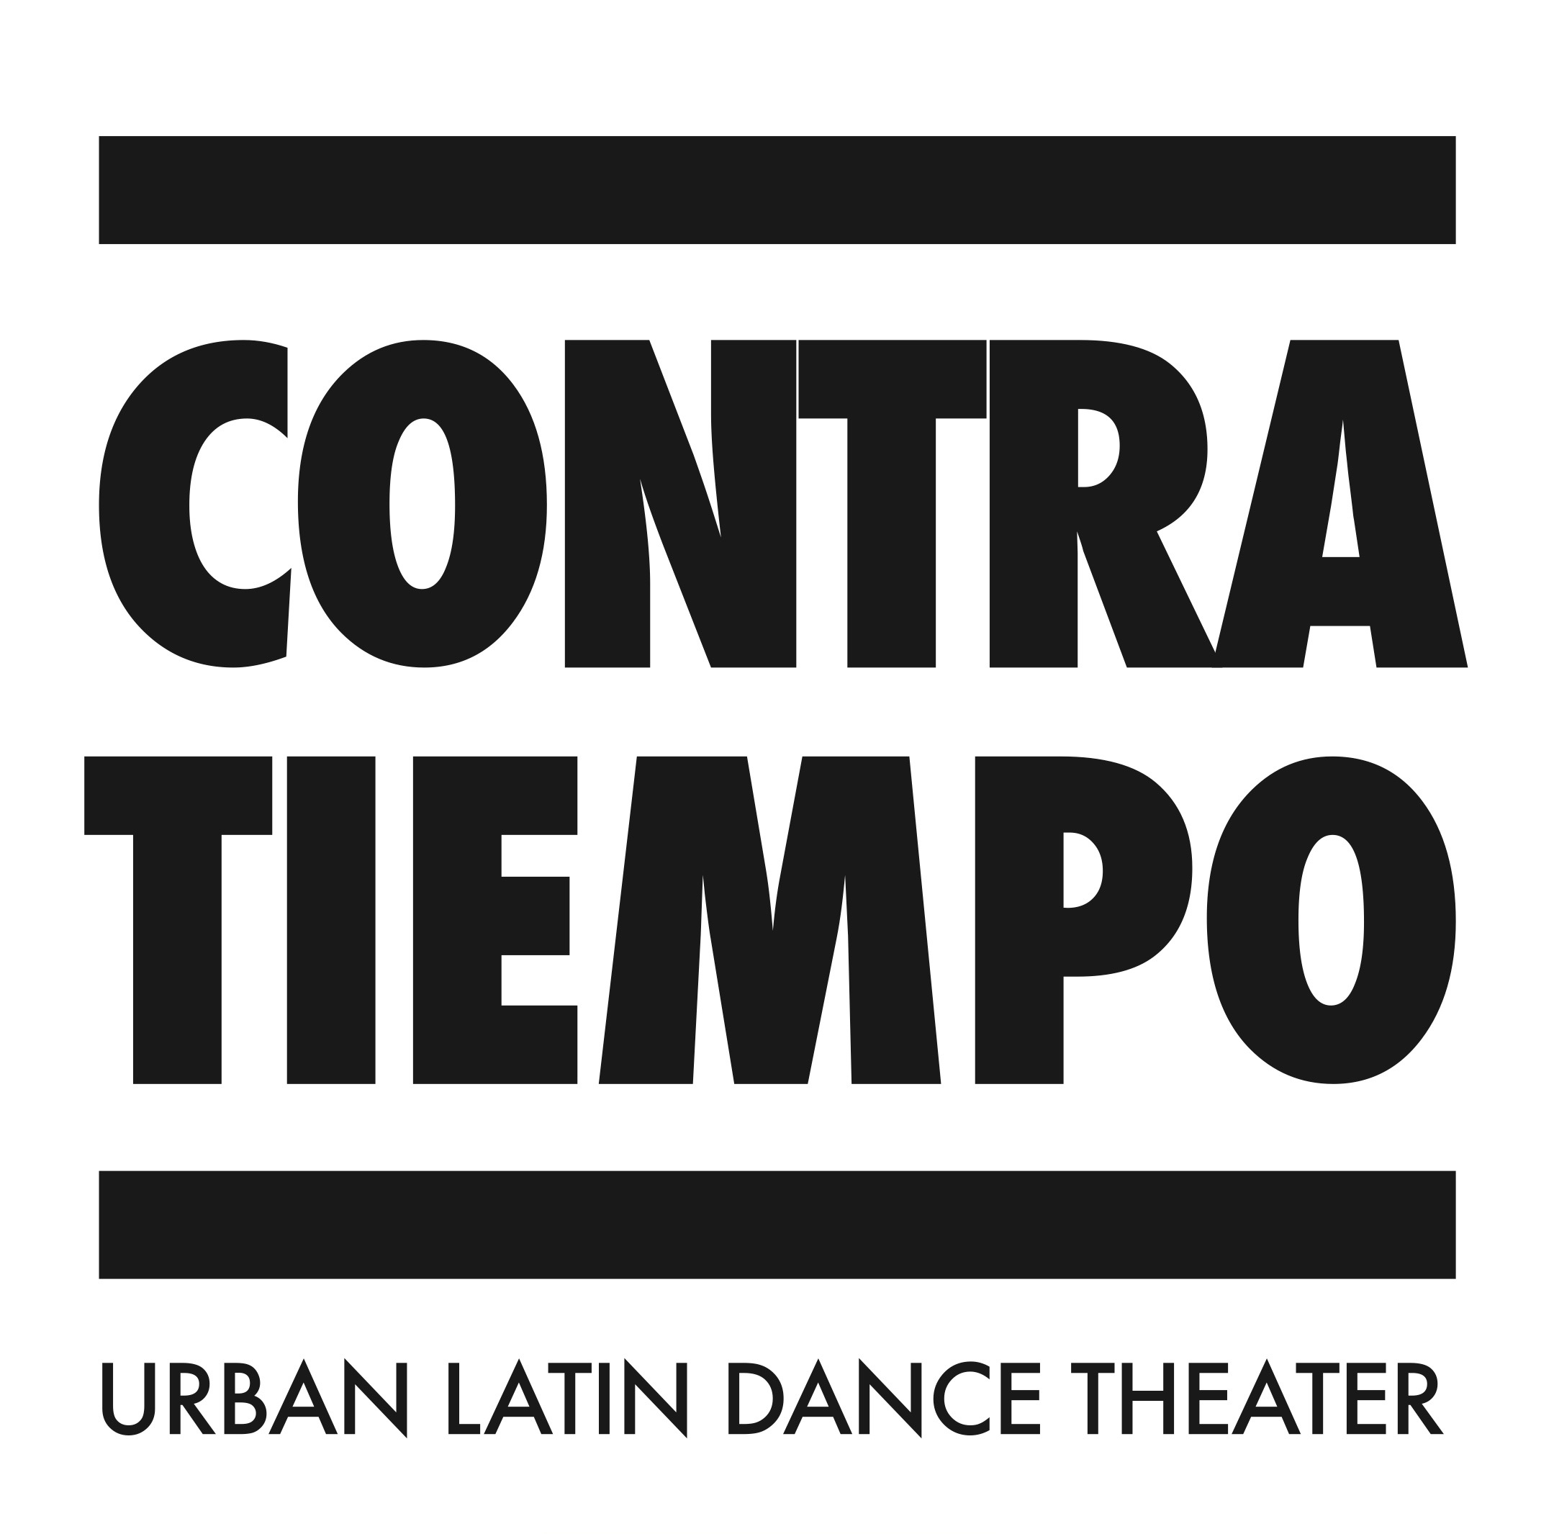
Please answer the following questions as honestly as possible. Do not exceed these 2 pages. Submit the form to toledo@contra-tiempo.org by April 5th, 2019 with your $35 non-refundable application fee (unless you are applying for Financial Aid, these will be turned in together on March 18th). This fee can be paid by check or credit card: contra-tiempo.org/futuro/#summer-dance-intensive. Please note that your application will NOT be screened or processed without the submission of the $35 application fee. This fee will be applied to your total tuition balance, if accepted into the program.
Participant First & Last Name:
Have you applied to the Futuro Summer Dance Intensive before? |  | If yes, did you participate? In what year?
Age: | Gender Pronoun: | Ethnicity (optional):
E-Mail: |  | Phone #:
Mailing Address:

FOR PARTICIPANTS 18 YEARS AND UNDER
Parent/Guardian First & Last Name:
Parent/Guardian Phone#:
Parent/Guardian Email:
Participant Grade/School: | Is this a Title 1 School? Y / N

- Have you had prior dance/performance training? If so, what kind and for how long?

- How did you hear about CONTRA-TIEMPO Futuro?

- Why is participating in the CONTRA-TIEMPO Futuro Summer Dance Intensive important to you?

- What are you hoping to get out of the CONTRA-TIEMPO Futuro Summer Dance Intensive, and how do you plan on applying that to your life outside of the program?

- What kind of artist and leader are you aspiring to become?

